**ASSIGNMENT**

**Module 5) HTML5**

1. **What are the new tags added in HTML5?**

**Ans:-** HTML5 introduced several new tags to enhance web development, focusing on improved semantics, multimedia, and overall functionality.

* **Semantic Elements :**

**<footer>:** Represents the footer for its nearest sectioning content or sectioning root element.

**<header>:** Represents the header of a section or page.

**<main>:** Specifies the main content of a document.

**<mark>:** Represents text highlighted for reference purposes.

**<nav>:** Defines navigation links.

**<section>:** Represents a standalone section that doesn't have a more specific semantic element to represent it.

* **Multimedia Elements :**

**<audio>:** Used to embed sound content.

**<video>:** Used to embed video content.

**<source>:** Specifies multiple media resources for media elements like <audio> and <video>.

1. **How to embed audio and video in a webpage?**

**Ans:**

* **Embedding Audio :** The <audio> element is used to embed sound content in a webpage. You can provide multiple source files to ensure compatibility with different browsers.

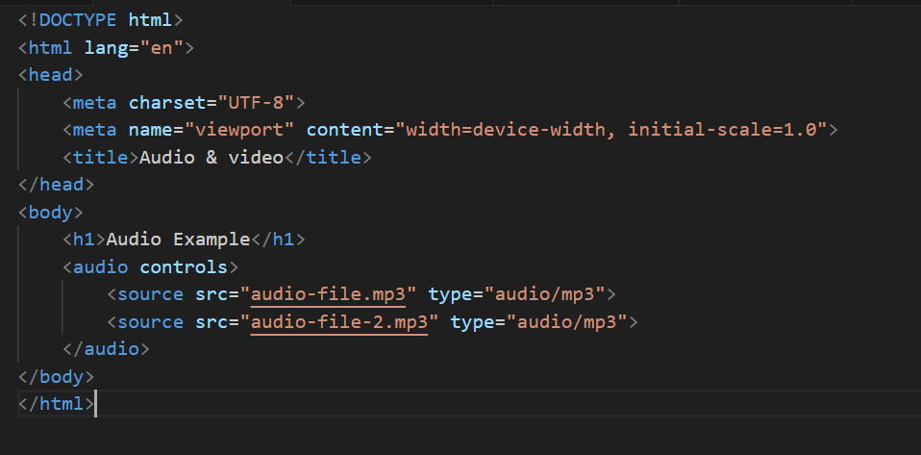

* **Embedding Video :** The <video> element is used to embed video content. Similar to the <audio> element, you can provide multiple sources.

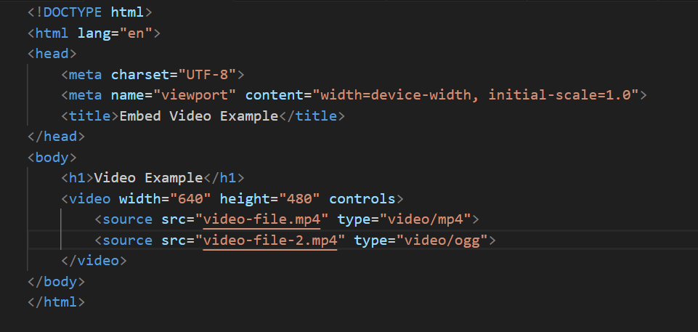

1. **Semantic element in HTML5?**

**Ans:**

* **Semantic Elements :**

**<footer>:** Represents the footer for its nearest sectioning content or sectioning root element.

**<header>:** Represents the header of a section or page.

**<main>:** Specifies the main content of a document.

**<mark>:** Represents text highlighted for reference purposes.

**<nav>:** Defines navigation links.

**<section>:** Represents a standalone section that doesn't have a more specific semantic element to represent it.

**Example of Semantic Element :-**

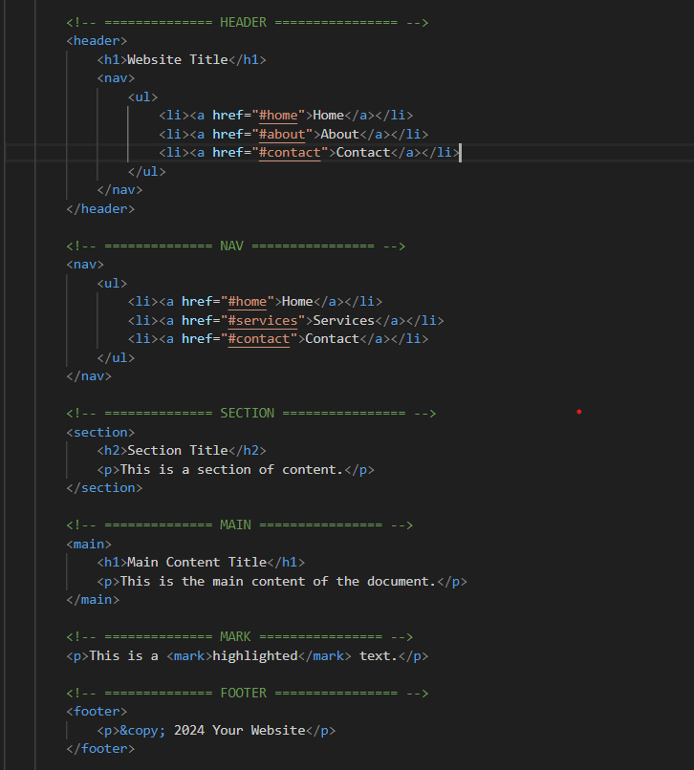

1. **Canvas and SVG tags**

**Ans:**

* **Canvas :** The <canvas> element is used to draw graphics via scripting (usually JavaScript). It is resolution-dependent and does not provide built-in functionality for drawing all drawing must be done via JavaScript.
* **SVG :** The <svg> (Scalable Vector Graphics) element is used to define vector-based graphics directly in the HTML. SVG is XML-based, providing more capabilities for graphics such as built-in shapes, styling, and transformations.

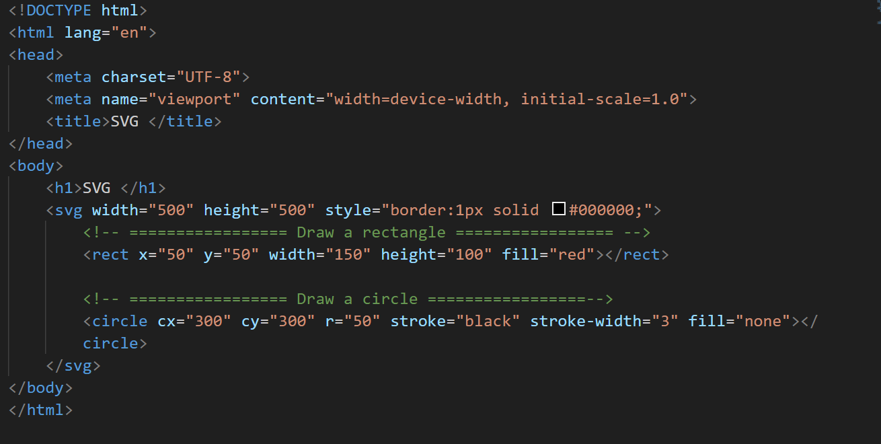**Example :**